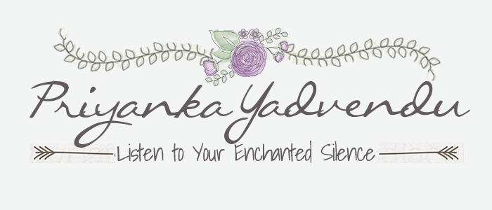

Living Your Vision Contract – Let Your Light Shine
The following terms binds (Insert Full Name) to living her vision with dignity and love and letting her light shine:
- I will live a love driven life.

- I will honor and love myself first and foremost above everything else. I understand that by making my happiness a priority, I will be able to present the best version of myself to others, including loved ones.

- I deserve a good man and I am worthy of healthy, beautiful love.

- I will let go and surrender to where and how life takes me.

- I will find power and peace in surrendering and letting go and will trust the process.

- People, places, or things cannot make me happy. Happiness can come only from within me.

- I am not perfect and neither is anyone else. I will hold myself and my loved ones to high expectations, but also understand life is a work in progress and I am always growing and learning.

Name _____________ Date _____________

© 2014 by Priyanka Yadvendu. All rights reserved.

